Lab_Day-5 (Functions)

1. Declare a div() function with two parameters. Then call the function and pass two numbers and display their division.

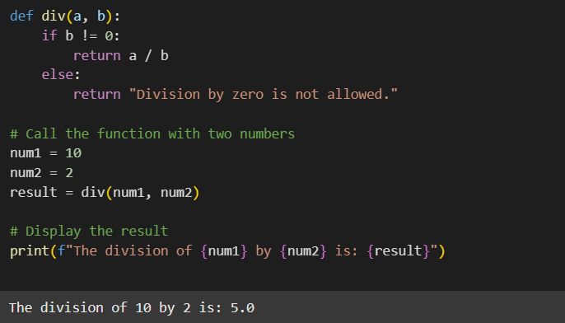

1. Declare a square() function with one parameter. Then call the function and pass one number and display the square of that number.

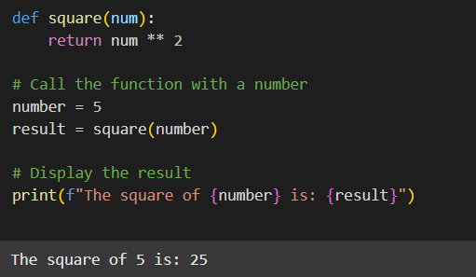

1. Using max() and min() functions display the maximum and minimum of 5 random numbers.

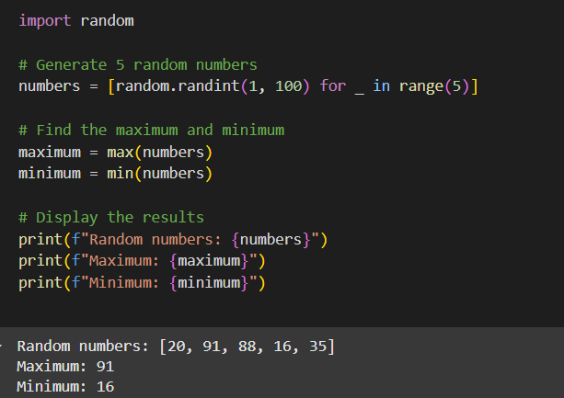

1. Accept a name from the user and display that in lower case using lower() function.

